We invite you to join us for
beyond Glaucoma 2021: Time for Glaucoma –
Are We Seeing Clinical Practice Clearly?
Friday 24th September 14:00 – 17:30 BST
or
Saturday 25th September 08:00 – 11:30 BST

REGISTER HERE

We look forward to bringing the eye care community together for a memorable and meaningful virtual event with live and on-demand engaging content.
Meet the Experts
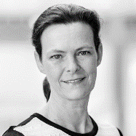  Ingeborg Stalmans  Belgium |  | Jonathan Crowston  Singapore | David Crabb  UK |  |  | Anthony Khawaja  UK |  | 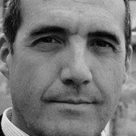Francisco Goñi  Spain |  | Herbert Reitsamer  Austria
Marta Pazos  Spain | Antonio Fea  Italy |  |  | Ike Ahmed  Canada | Paul Harasymowycz  Canada |  | 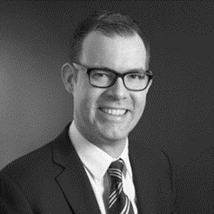Nathan Kerr  Australia |  | Yi Xing  China

Adverse events should be reported. Reporting forms and information can be found at https://yellowcard.mhra.gov.uk/.
Adverse events should also be reported to Allergan Ltd. UK_Medinfo@allergan.com or 01628 494026.

Placeholder for Prescribing Information, Directions For Use
and local adverse event reporting information, if required

